

**Waiver Form Instructions**

Dear Room Parent,

As you already know, the PTA has transitioned all paperwork completely online this year, including membership, spiritwear, volunteering, and waiver forms.

The most critical of these to have completed is the PTA waiver form which allows all children to participate in PTA sponsored activities such as Jog-a-thon. We have set-up a report that you (as a room parent) can access from the PTA website to see which students we have a waiver on file.

Once you have received a class roster from your teacher, we request that you compare the online report for your classroom to your class roster and contact those parents individually who do not have a waiver form on file.

On the 2nd page of this document is a sample email you can use and modify to send to those families who still need to complete waiver forms. You can also find this sample email on the Room Parent Central website to download and modify as needed.

**Room Parent Instructions to Access Reports from Website:**

To access the report for your classroom, please login (using your regular parent email address login information) at www.portolaspringspta.org and click on the “Admin” link on the top right.  Once you are taken to the admin page, you will see all reports that you have permission to view (which will probably just be the waiver report for your classroom unless you are also a committee lead).

Thank you,

Portola Springs PTA

**Sample Email:**

 Dear <Parent1> and <Parent2>,

My name is <room parent name>.  <2nd room parent> and I will be room parents for Mrs. <teacher’s> class this year. We will be sending a welcome letter home soon with details about the upcoming school year. However, we do not currently have a PTA waiver form on file for your child. In order for <child’s name> to participate in PTA sponsored events at school, such as Jog-a-thon, Family Fun Events, etc…, we need a completed waiver form. Can you please complete the online back-to-school PTA forms in order for us to have a completed waiver on file at your earliest convenience at the following website:  [www.portolaspringspta.org/Packet/BTSP/](http://www.portolaspringspta.org/Packet/BTSP/)

If you have already completed the Back-To-School PTA packet and just need to complete the waiver form, please click here to be taken directly to the waiver form:  <http://portolaspringspta.org/Packet/PTA%20Waiver%20Form>

Please note, you are not obligated to join PTA or purchase anything to complete the waiver. The waiver form is on page 3 of the back-to-school PTA packet and is demonstrated in a picture below. If you choose not to join PTA, order spiritwear, etc… please just click the “Next” button on those pages to continue past them. If you have any questions, please feel free to contact me.

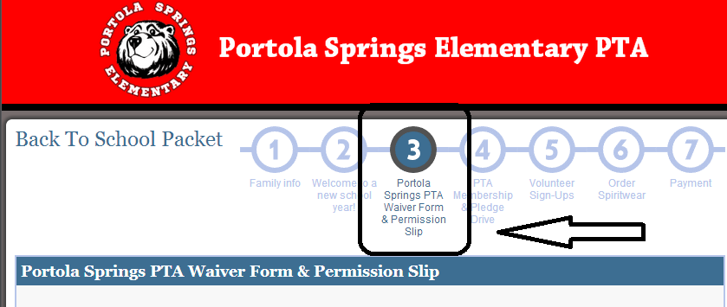

 Sincerely,

<Room Parent>